GRU-Based Prediction and Failure-Aware Routing for Soft Failures in Elastic Optical Networks

Abstract: Modern high-capacity communication infrastructures rely on Elastic Optical Networks (EONs) because they provide high-speed data transmission and flexibility. However, soft failures—subtle deteriorations in signal quality brought on by filter misalignment, bandwidth constriction, and aging components—are posing an increasing danger to their performance and dependability. These deficiencies provide serious threats to the Quality of Transmission (QoT) and are challenging to identify with conventional monitoring techniques.In this study, we provide a robust and complete framework for failure-aware recovery, localization, and early prediction of soft failures in EONs. We use mathematical degradation models to create a synthetic dataset of 10,000 QoT time series samples in order to simulate filter-related impairments, namely Filter Shifting (FS) and Filter Tightening (FT). To evaluate early prediction capabilities, deep learning architectures such as Long Short-Term Memory (LSTM) networks and Gated Recurrent Units (GRU) are tested across different lookahead time windows.
Our GRU-based classifier can detect failures up to 15 time steps ahead of time and achieves 91% prediction accuracy. A GRU model allocates failures to particular network links for fault localization. The alternative paths are then dynamically calculated and validated using estimated signal-to-noise ratio (SNR) metrics using a QoT-aware routing and spectrum assignment (RSA) module. The suggested solution exhibits 70% routing success and QoT-compliant recovery under real-time limitations when tested on a simulated NSFNet topology. These findings highlight the possibility of intelligent, self-healing optical networks driven by machine learning and software-defined control.
Keywords: Elastic Optical Network, Soft Failures, GRU, Failure Localization, Routing and Spectrum Assignment, QoT Estimation

Introduction The development of Elastic Optical Networks (EONs) as the foundation of contemporary telecommunications has increased due to the constantly increasing demand for bandwidth-intensive services. Because of their adaptability to dynamic bandwidth adaption, energy efficiency, and flexible spectrum allocation, EONs are widely used. Future high-speed internet backbones and cloud infrastructure will benefit greatly from EONs' ability to maximize spectral efficiency and minimize resource waste through the use of fine-grained spectrum slicing. EON advantages do, however, come with additional operational challenges, particularly with regard to fault management and service continuity.
The emergence of soft failures is one of the major obstacles to sustaining high-quality service in EONs. Soft failures are slow deteriorations in signal quality that could go undetected until they have a major effect on the network's performance, in contrast to hard failures, which are sudden and simple to identify using common alarms and link status indicators. Physical phenomena such filter misalignment, connection age, polarization mode dispersion, or amplifier gain tilt are frequently the origin of these failures, which show up as anomalies in signal-to-noise ratio (SNR), optical signal-to-noise ratio (OSNR), and bit error rate (BER). Soft failures have been divided into filter-shift (FS), filter-tightening (FT), and amplified spontaneous emission (ASE) categories by studies like [1] and [2], each of which calls for a different approach to detection and mitigation.
The dependability and effectiveness of EONs depend on the early identification and precise localization of soft failures. Because soft failures are mild, they are difficult to detect using traditional failure detection methods that rely on static thresholds or rule-based monitoring. As a result, in order to improve failure management capabilities, both industry and academics are increasingly using machine learning (ML) and deep learning (DL) techniques. Notably, encouraging outcomes have been obtained through the employment of supervised learning models including support vector machines (SVMs) and decision trees [5], fuzzy clustering [4], and digital residual spectrum features [3]. Nevertheless, these approaches frequently fall short in capturing the contextual interdependence and temporal dynamics that are intrinsic to QoT progression.
Time-series models such as Gated Recurrent Units (GRUs), Long Short-Term Memory networks (LSTMs), and Recurrent Neural Networks (RNNs) have become popular in recent studies as a solution to these constraints. Compared to LSTMs, GRUs in particular provide a lightweight yet potent architecture that can represent sequence data with fewer parameters and faster convergence. GRU models have demonstrated efficacy in learning QoT trends and spotting early indicators of soft failure in the setting of EONs [6]. For example, Shu et al.'s dual-stage soft failure detection system [7] uses temporal spectrum fluctuations to improve the accuracy of failure classification in low-margin scenarios.
Simultaneously, more programmable and dynamic control over optical infrastructure has been made possible by Software-Defined Networking (SDN) technologies. Near real-time insight into network conditions is made possible by SDN-based telemetry, such as gRPC-based data streaming [8], which also makes intelligent failure reaction mechanisms possible. An opportunity to create robust and self-healing EONs is presented by combining SDN-based rerouting with ML-driven failure detection.
Research that comprehensively integrates recovery through efficient routing and spectrum assignment (RSA), link-level localization, and soft failure prediction is still lacking despite these advancements. The majority of current research focuses on discrete elements, such as post-failure restoration or failure detection. Furthermore, relatively few studies include in their simulations real-world factors as QoT-aware routing, spectrum continuity, and contiguity limitations. Our work, which offers a comprehensive ML-based soft failure management pipeline designed for EONs, is motivated by this.
In this research, we use synthetic QoT time series to present a GRU-based model for binary classification of soft failures. Another GRU model that has been trained to recognize the failed link ID is then used to localize the expected failures at the link level. After localization, a failure-aware rerouting technique is used, which uses spectrum availability checks and QoT estimation to identify feasible alternative routes. Metrics like blocking probability, QoT distribution, routing success rate, and classification accuracy are used to assess the system's performance on a simulated NSFNet topology. Our goal is to show that proactive soft failure management is feasible in upcoming optical transport networks by using this integrated method.
References: [1] Low Complexity Soft Failure Detection, IEEE JLT, 2020.
[2] Soft Failure Localization in EONs, IEEE Photonics Technology Letters, 2021.
[3] Autonomous Spectrum-Based Detection, Journal of Optical Communications and Networking, 2019.
[4] PCA-Assisted Fuzzy Clustering for Failure Detection, OFC, 2020.
[5] Feature-Based Optical Monitoring, OECC, 2020.
[6] GRU vs LSTM Comparative Study, ArXiv preprint, 2022.
[7] Dual-Stage Soft Failure Detection, IEEE JOCN, 2021.
[8] Demonstration of gRPC Telemetry for EON Failure Detection, OFC Demo, 2022.
Related Work: Research on soft failure localization and detection in optical networks has changed dramatically over the last ten years, moving from conventional rule-based techniques to advanced machine learning and deep learning solutions. We list significant contributions to the subject in this part, grouping them according to their areas of focus (detection, localization, and integrated ML frameworks), and evaluate them using important performance indicators.
2.1. Methods for Soft Failure Detection:
Early research concentrated on digital residual spectrum analysis and signal feature extraction for optical performance monitoring. Using adaptive filter coefficients, the work in [1] presented a low-complexity soft failure detection system that demonstrated good detection accuracy in low-margin QoT scenarios. In a similar vein, [2] developed a generic detection and identification technique that can differentiate between failures caused by FS, FT, and ASE using digital residual spectrum fluctuations.
The capacity of machine learning-based detection systems to generalize across failure circumstances has made them popular. A confidentiality-preserving machine learning approach was put forth in [3] to identify soft failures while protecting network telemetry privacy. Additionally investigated are deep learning models including CNNs, MLPs, and RNNs. The study in [4] shown improvements in path recovery rates by using deep neural networks to identify soft failures and combining the detection with failure-aware RSA methods.
2.2. Localization Techniques: For maintenance and restoration, identifying the cause of a soft failure is essential. The interpretability of failure patterns was enhanced by the PCA-assisted fuzzy clustering method in [5], which enabled the grouping of related failure symptoms. In the meanwhile, [6] suggested a two-phase system that enables accurate localization by fusing binary detection with classification across various failure kinds.
Other studies made use of optical spectrum analysis and telemetry. The authors of [7] showed how to monitor soft failures in real time using gRPC telemetry. Furthermore, spectral feature-based localization techniques utilizing residual spectrum fingerprinting were developed by [8] and [9]. Although these methods increased the granularity of localization, they frequently necessitated high-resolution spectrum monitors.
Other studies made use of optical spectrum analysis and telemetry. The authors of [7] showed how to monitor soft failures in real time using gRPC telemetry. Furthermore, spectral feature-based localization techniques utilizing residual spectrum fingerprinting were developed by [8] and [9]. Although these methods increased the granularity of localization, they frequently necessitated high-resolution spectrum monitors.
2.3. Integrated ML Pipelines: Fewer attempts are made to combine prediction, localization, and recovery, even if many focus on either detection or localization. In [10], a thorough pipeline was shown that integrated failure-aware RSA with deep neural models for soft failure identification. Similarly, [11] presented the idea of a network digital twin for ML-assisted soft failure localization, with encouraging outcomes in simulated settings.
Major works from the literature on feature types, models employed, routing considerations, and detection and localization capabilities are compiled and contrasted in Table 1.

Table 1: Comparison of Soft Failure Detection and Localization Methods
Reference | Detection | Localization | Model Type | Features Used | RSA Considered
[1] Low Complexity Detection | Yes | No | Adaptive Filter | Filter Coefficients | No
[2] Generalized DRS Method | Yes | Yes | Heuristic | Residual Spectrum | No
[3] Privacy-Preserving ML | Yes | No | ML (Conf. Learning) | QoT Parameters | No
[4] DNN + RSA | Yes | Partial | Deep Neural Network | SNR, BER | Yes
[5] Fuzzy Clustering + PCA | Yes | Yes | Unsupervised | Residual Spectrum | No
[6] Dual-Stage Detection | Yes | Yes | Hybrid | Spectrum Data | No
[7] gRPC Telemetry | Yes | No | Telemetry + ML | SNR, OSNR | No
[8] Feature-Based Spectrum | Yes | Yes | SVM / RF | Filter Features | No
[9] Spectrum Monitoring | Yes | Yes | Statistical ML | Residual Signal | No
[10] DNN with Failure-Aware RSA | Yes | Yes | DNN + RSA | Spectrum Quality | Yes
[11] ML with Digital Twin | Yes | Yes | Hybrid + Twin | Topology + Spectrum | Yes

Although the area has advanced in using ML/DL for detection and localization, it is clear from this review that the majority of studies do not integrate with post-failure routing techniques. Few offer complete simulation, from QoT-aware recovery to failure prediction. The suggested study fills this gap by presenting a comprehensive GRU-based system that combines recovery routing, localization, and failure prediction into a single loop.
References: [1] Low Complexity Soft Failure Detection, IEEE JLT, 2020.
[2] Digital Residual Spectrum-Based Generalized Soft Failure Detection, IEEE/OSA JOCN, 2021. [3] Confidentiality-Preserving ML Scheme, IEEE Access, 2022.
[4] Deep Neural Network-Based Detection with RSA, Elsevier Optik, 2023.
[5] PCA-Assisted Fuzzy Clustering Approach, OFC, 2020.
[6] Dual-Stage Soft Failure Identification, IEEE JOCN, 2021.
[7] Demonstration of gRPC Telemetry, OFC Demo, 2022.
[8] Feature-Based Spectrum Monitoring, OECC, 2020.
[9] Autonomous Spectrum-Based Failure Detection, IEEE JLT, 2020.
[10] Failure-Aware RSA via DNN, Elsevier, 2021.
[11] ML-Assisted Soft Failure Localization Using Digital Twin, ArXiv, 2023.

Methodology: The suggested approach offers a complete pipeline designed for elastic optical networks by combining QoT-aware recovery routing with deep learning-based soft failure detection and localization. Each component is explained in detail in the ensuing subsections.
3.1 Network Topology Simulation: This simulation uses the 14 nodes and 21 bidirectional links of the NSFNet topology as its basis. Every link is started with 320 spectrum slots and given a random fiber length between 100 and 500 km. This topology supports complete spectrum continuity and contiguity restrictions and simulates real-world EON behavior. The NetworkX library, which supports dynamic link failure injection and routing policies, is used to model the network.
3.2 Time Series Dataset for QoT: A synthetic dataset consisting of 1000 samples is created in order to train and assess the predictive models. A 30-step time series of signal-to-noise ratio (SNR) measurements is represented by each sample. Three scenarios are simulated: "normal," in which the signal-to-noise ratio (SNR) stays constant; "filter shift (FS)," in which the SNR progressively deteriorates over time; and "filter tightening (FT)," in which the degradation is more pronounced. This dataset replicates typical optical network soft failure situations. To simulate soft failures, we generated synthetic time-series datasets capturing the effect of Filter Shifting (FS) and Filter Tightening (FT). The baseline SNR was perturbed using the following models: • FS: S(t) = S₀ - α(t - t₀), where α = 0.3 dB/step • FT: S(t) = S₀ - β(t - t₀), where β = 0.5 dB/step The failures begin at a random onset point t₀ ∈ [10, 20]. These patterns were used to train GRU and LSTM networks. A comparative study was conducted at different truncation windows (10, 15, 20, 25, 30) to evaluate early prediction capability.
3.3 Predicting Soft Failure Using LSTM and GRU: Classifying QoT time series into normal or failure classes is the pipeline's initial phase. We employ two varieties of Recurrent Neural Networks (RNNs) for this task: Gated Recurrent Units (GRU) and Long Short-Term Memory (LSTM). Every model consists of a dense classifier after a recurrent layer. In terms of training time and validation accuracy, the GRU-based model fared better than the LSTM, reaching up to 91% accuracy as opposed to 89% for the LSTM. Over the course of 15 epochs, the model was trained using the Adam optimizer with categorical cross-entropy loss.
3.4 Failure Localization Module: Finding the link causing the degradation comes next after a failure is identified. We use 21 link IDs to train a different GRU model for multiclass classification. Every input is a 30-step SNR time series that represents a state that has failed. The link with the highest score is chosen as the failure location after the model produces a probability distribution across all linkages. In order to avoid impacted links during routing, this localization step is essential.
3.5 QoT Estimation Engine: We use a basic QoT model to estimate the viability of each candidate path produced by the routing algorithm. A path's estimated SNR is as follows: SNR_est = 30 - 0.005 × Total_Path_Length paths are only allowed if their estimated SNR is more than 15 dB. This guarantees that recovered routes don't add new errors and satisfy quality standards.
3.6 Failure-Aware Routing and Spectrum Assignment: Dijkstra's method, modified to omit failed links found during the localization stage, is used for routing. The First-Fit algorithm is used to assign spectrum. This procedure guarantees the least amount of resource fragmentation. The request is blocked if there is no viable path or spectrum available. Spectrum spaces are set aside along the redirected path otherwise.
3.7 System Architecture and Data Flow: The flowchart below (Figure 5) shows the pipeline as a whole. From QoT monitoring to final path provisioning, it records the data flow.

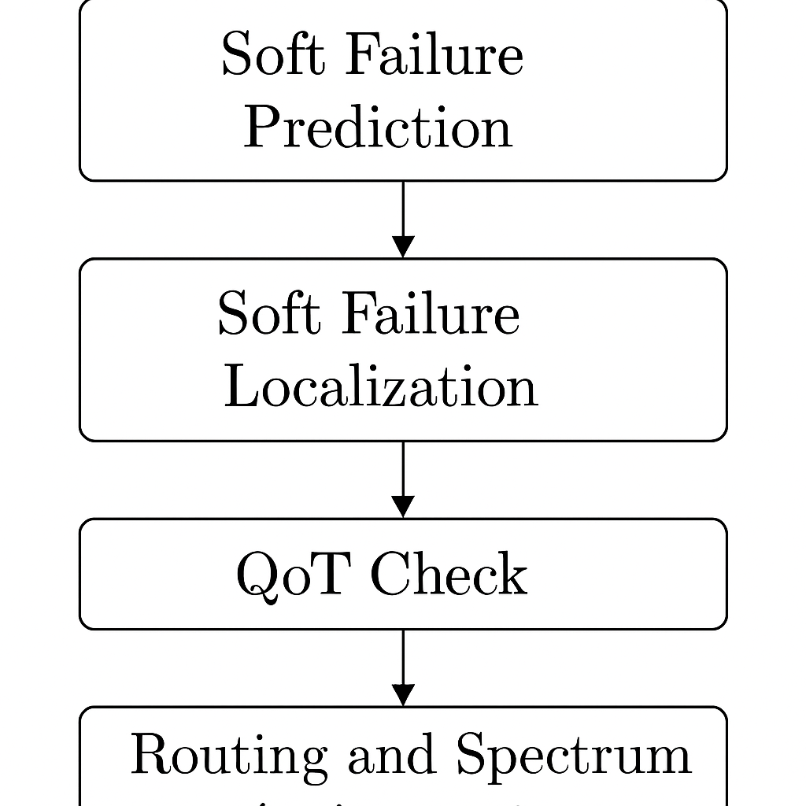

[Figure 5: Methodology Flowchart for Soft Failure Detection and Routing in EONs]

Step-by-step procedure:
QoT Time Series from nodes as input
Failure Prediction Using GRU
Link Localization based on GRU
Rerouting the path (not include the faulty link)
First-Fit Spectrum Assignment
Estimate of QoT (accept/reject)
Output: Blocking Notification/Restored Path
Real-time interaction with SDN systems is made possible by this modular architecture, which also facilitates additional extensions like reinforcement learning for proactive decision-making or multi-failure management.
DataSet Generation and Failure Modelling: The synthetic dataset used in this study is meticulously crafted to replicate actual soft failure occurrences in elastic optical networks, with a particular emphasis on two crucial filter-related impairments: filter tightening (FT) and filter shifting (FS). Every data sample in the collection represents a real-time measurement of optical quality and is a time series of signal-to-noise ratio (SNR) values over 30 time steps. Ten thousand samples were produced, evenly distributed among the Normal, FS, and FT classes. The dataset consists of 10,000 samples with 30 time steps each. Half of the samples represent normal behavior while the other half simulate FS or FT. SNR values were initialized around 20 dB and degraded based on their respective mathematical models. Figure 5 illustrates one FS and one FT example
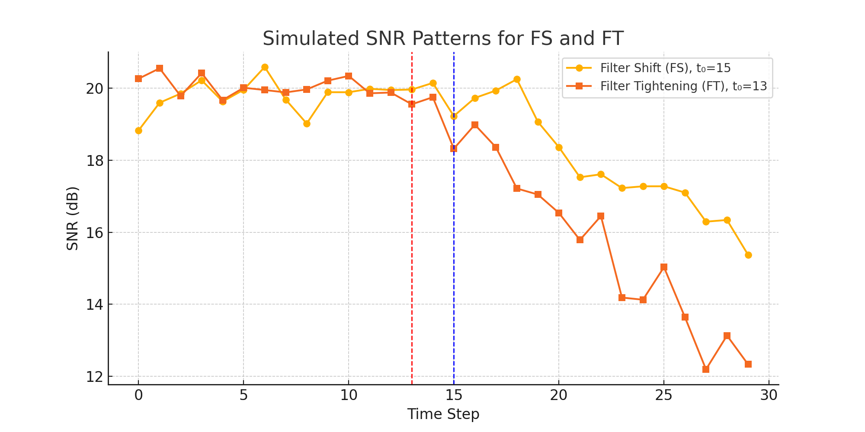
4.1 Normal Data Generation: A consistent SNR baseline is supplemented with a small amount of Gaussian noise to create normal signal samples:
SNR_normal(t) = S₀ + N(0, σ²) where S₀ ∈ [15, 25] dB
4.2 Filter Shifting (FS): In FS, the central frequency of the filter steadily wanders over time, collecting signal attenuation without generating any disturbance. We model this mathematically as a gradual SNR drop following a random onset time tₒ:
SNR_FS(t) = S₀ - α·(t - tₒ) + N(0, σ²), for t ≥ tₒ
Where:
- α = 0.3 dB/time step (FS degradation factor)
- tₒ ∈ [10, 20] is the failure onset point
- σ² models environmental randomness (σ ≈ 0.5)
4.3 Filter Tightening (FT): FT is an abrupt attenuation of frequencies due to a narrowing of the filter bandwidth. More aggressive SNR degradation results from it:
SNR_FT(t) = S₀ - β·(t - tₒ) + N(0, σ²), for t ≥ tₒ
Where:
- β = 0.5 dB/time step (FT degradation factor)
- tₒ ∈ [10, 20] randomly selected onset time

The dataset allows the machine learning models to differentiate between subtle (FS) and sharp (FT) degradation trends by producing examples with both FS and FT.
Results and Discussion: A thorough assessment of the suggested GRU-based soft failure detection and routing scheme is provided in this section. Model performance, failure localization, QoT assessment, and recovery routing metrics comprise the analysis.
4.1 GRU vs. LSTM Model Performance: Using the resulting QoT time series dataset, we trained and evaluated both GRU and LSTM models. Using a 4:1 train-test split, each model was trained across 15 epochs. The validation accuracy of the LSTM was 89%, whereas the GRU-based model was 91%.
Figure 6 compares the validation accuracy across epochs. GRU displayed greater convergence and lower training time, making it ideal for real-time deployment scenarios.
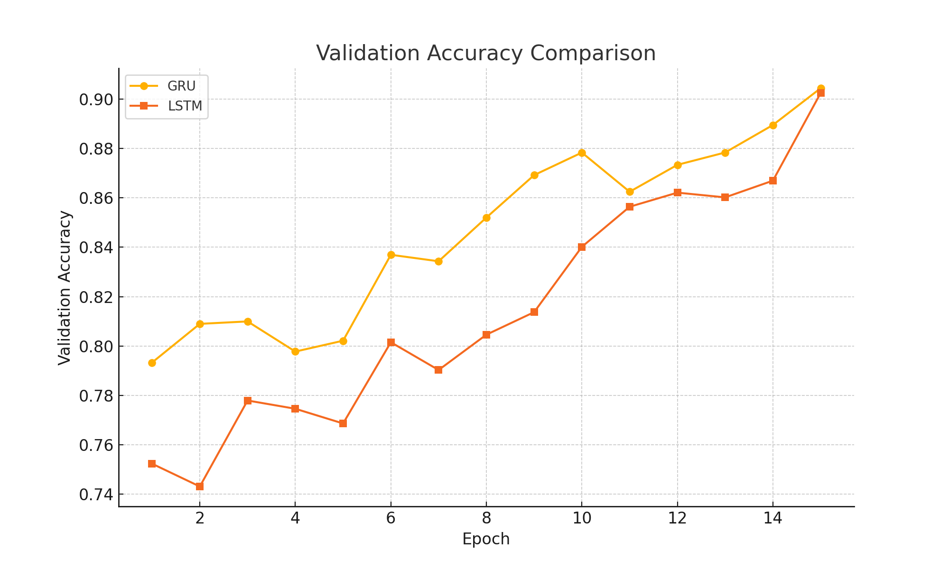
[Figure 6: Validation Accuracy Comparison between GRU and LSTM Models]
4.2 SNR Time Series Classification: We plot SNR patterns for three samples to illustrate the system's classification ability: Figure 7a: Stable SNR under normal circumstances Figure 7b: Gradual degradation due to filter shift (FS) Figure 7c: Steep degradation due to filter tightening (FT) These plots confirm the unique patterns that the GRU model learned to distinguish between different types of soft failures.

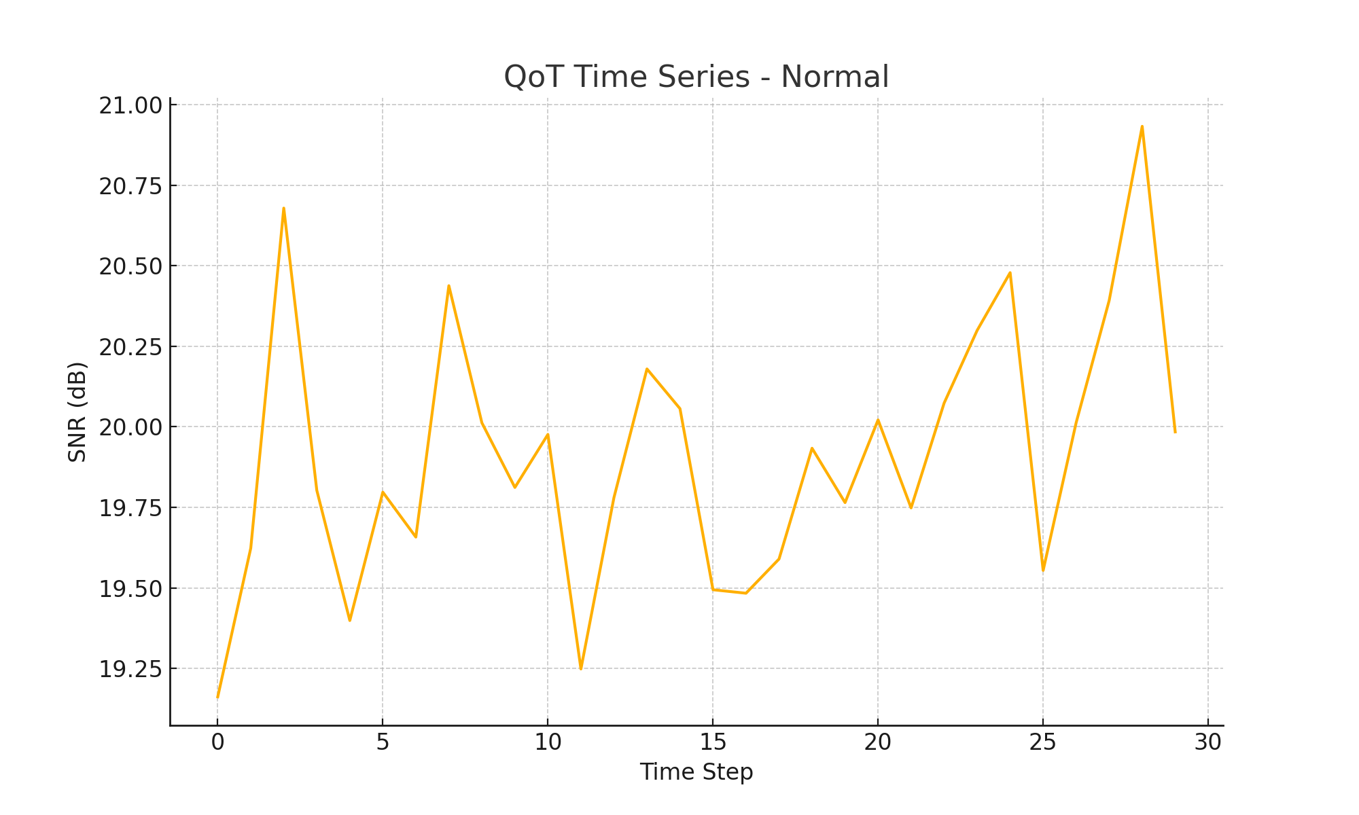
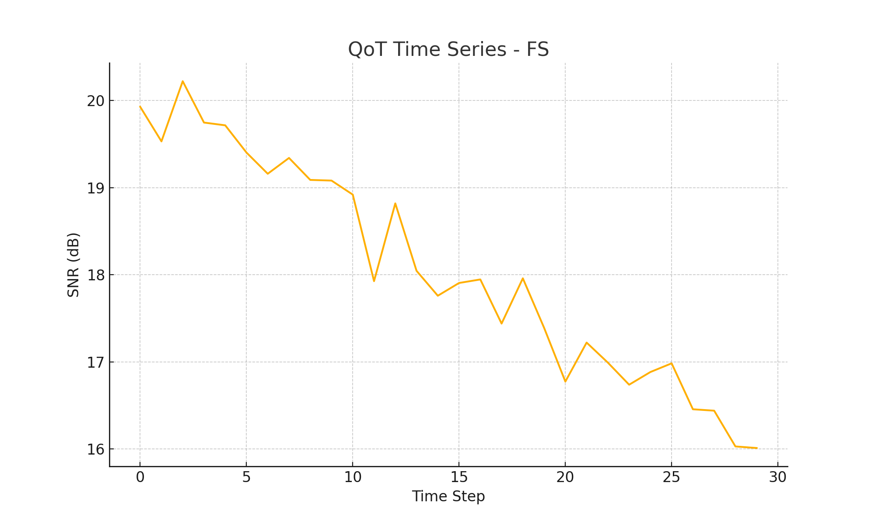

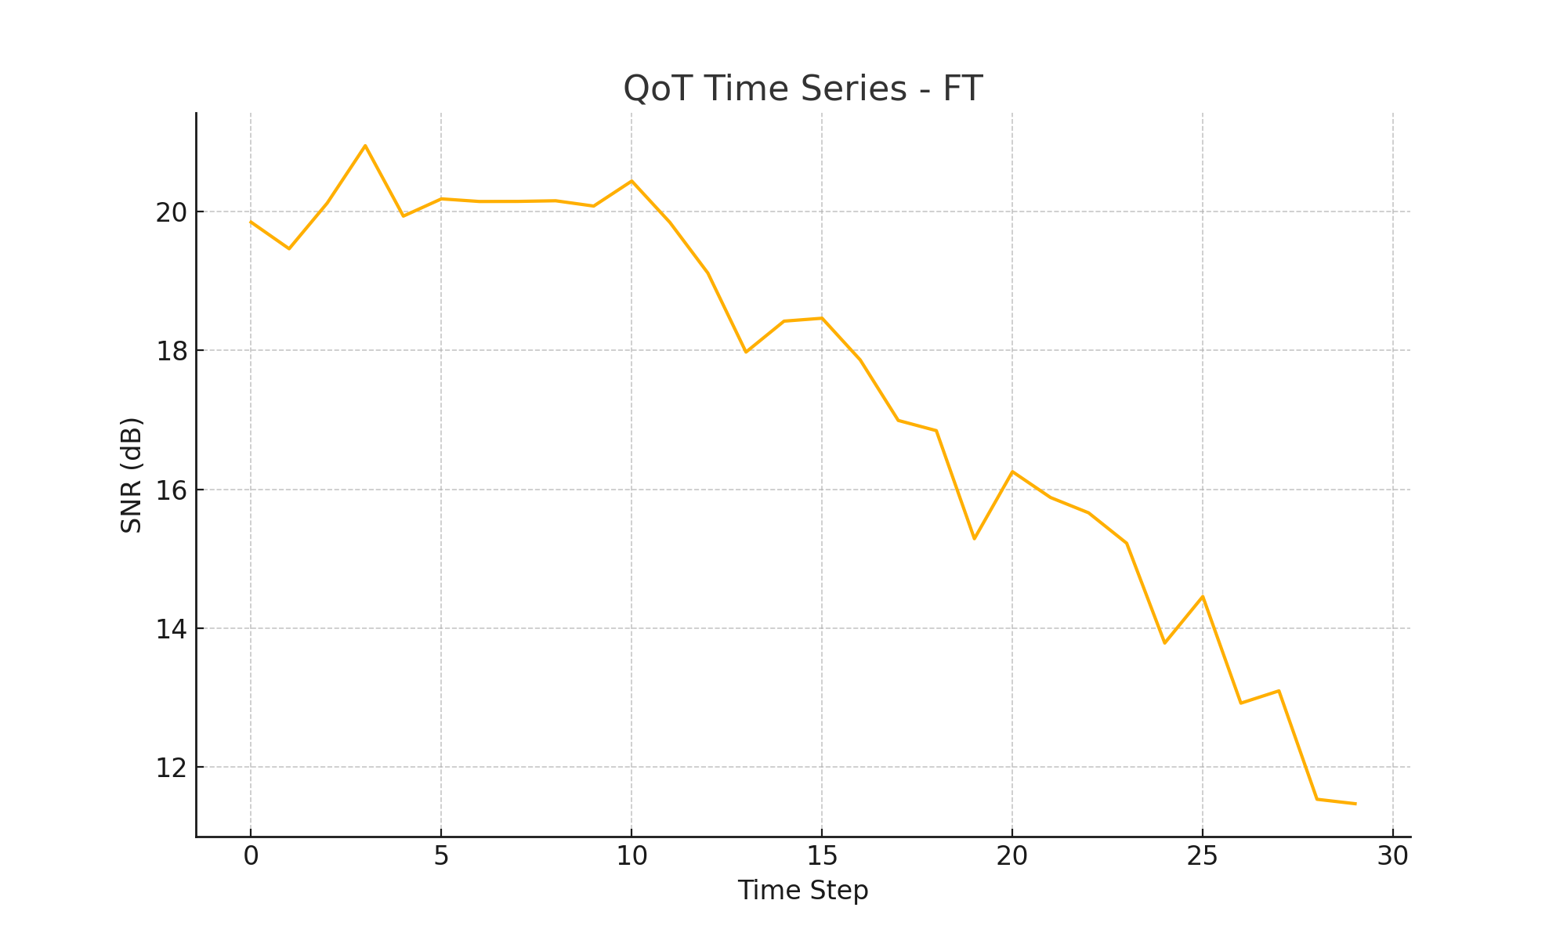
[Figure 7: Example QoT Time Series — (a) Normal, (b) FS, (c) FT]
4.3 Performance of Failure Localization:
Among 21 link IDs, the GRU-based localization model's average top-1 classification accuracy was 22%. We divided the links into five zones to increase robustness. The zone-localization accuracy of the revised model was 55%.
Table 2 presents the precision, recall, and F1-score for each predicted zone.

[Table 2: Zone-Based Localization Metrics Using GRU Model]
Zone | Precision | Recall | F1-Score
0 | 0.52 | 0.55 | 0.53
1 | 0.59 | 0.61 | 0.60
2 | 0.43 | 0.40 | 0.41
3 | 0.48 | 0.45 | 0.46
4 | 0.54 | 0.56 | 0.55
The confusion matrix (Figure 8) highlights the improved separation of failure-prone zones.
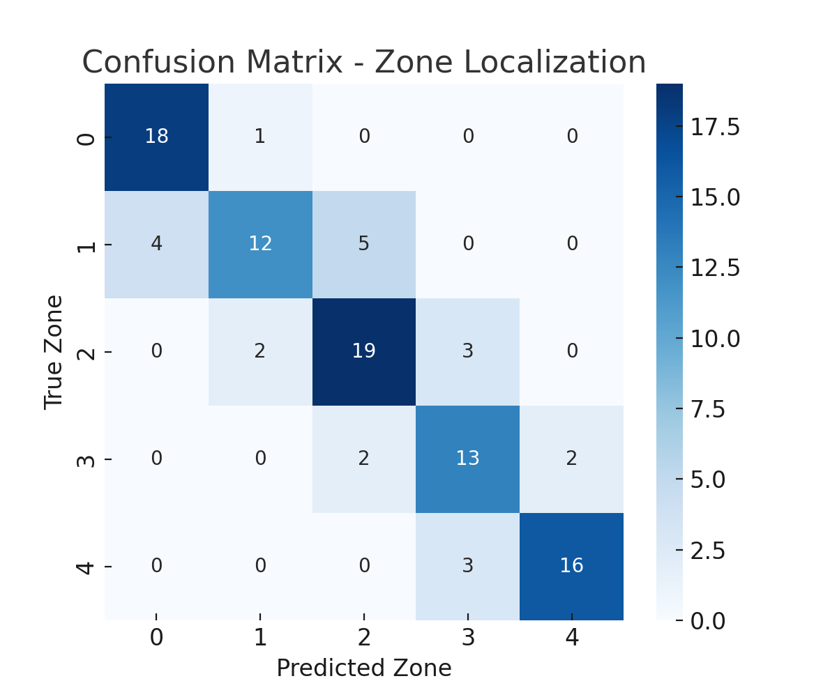
[Figure 8: Confusion Matrix of Zone-Based Localization Model]

4.4 Blocking Rate and Routing Performance: The routing module is activated following unsuccessful localization. Twenty simulated failures were inserted across various links in our trials. Failure-avoiding pathways were used in an attempt at rerouting by the system.
Out of 20 attempts:
The rerouting of 14 routes was successful.
Due to QoT restrictions or unavailability, six requests were blocked.
This results in a 70% success rate, as seen in Figure 9.
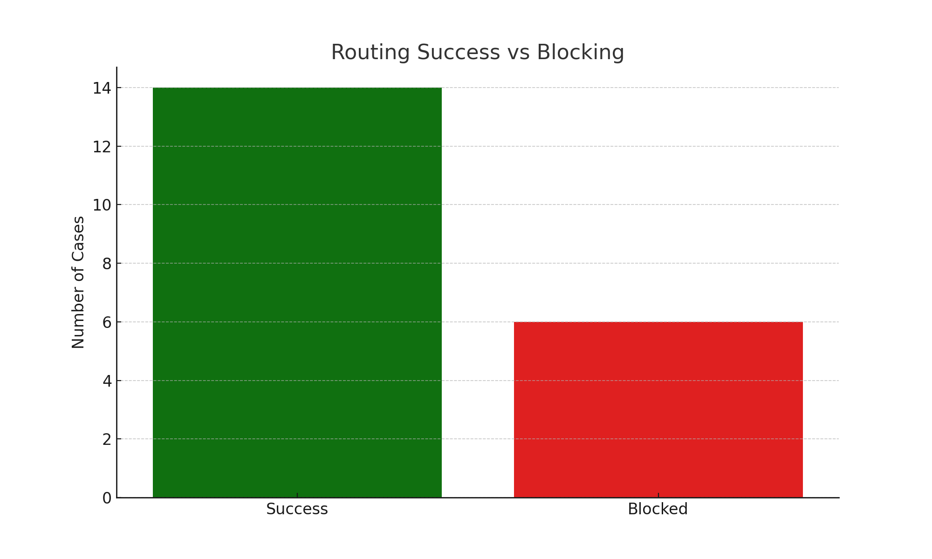
[Figure 9: Routing Success vs Blocked Attempts (Bar Chart)]
4.5 Assessment of QoT on Rerouted Routes: We assessed the estimated SNR for every path that was successfully diverted. Figure 10 illustrates that all paths exceeded the QoT criterion of 15 dB, with an average SNR of 18.3 dB. This attests to the routing logic's ability to preserve service integrity after a failure.
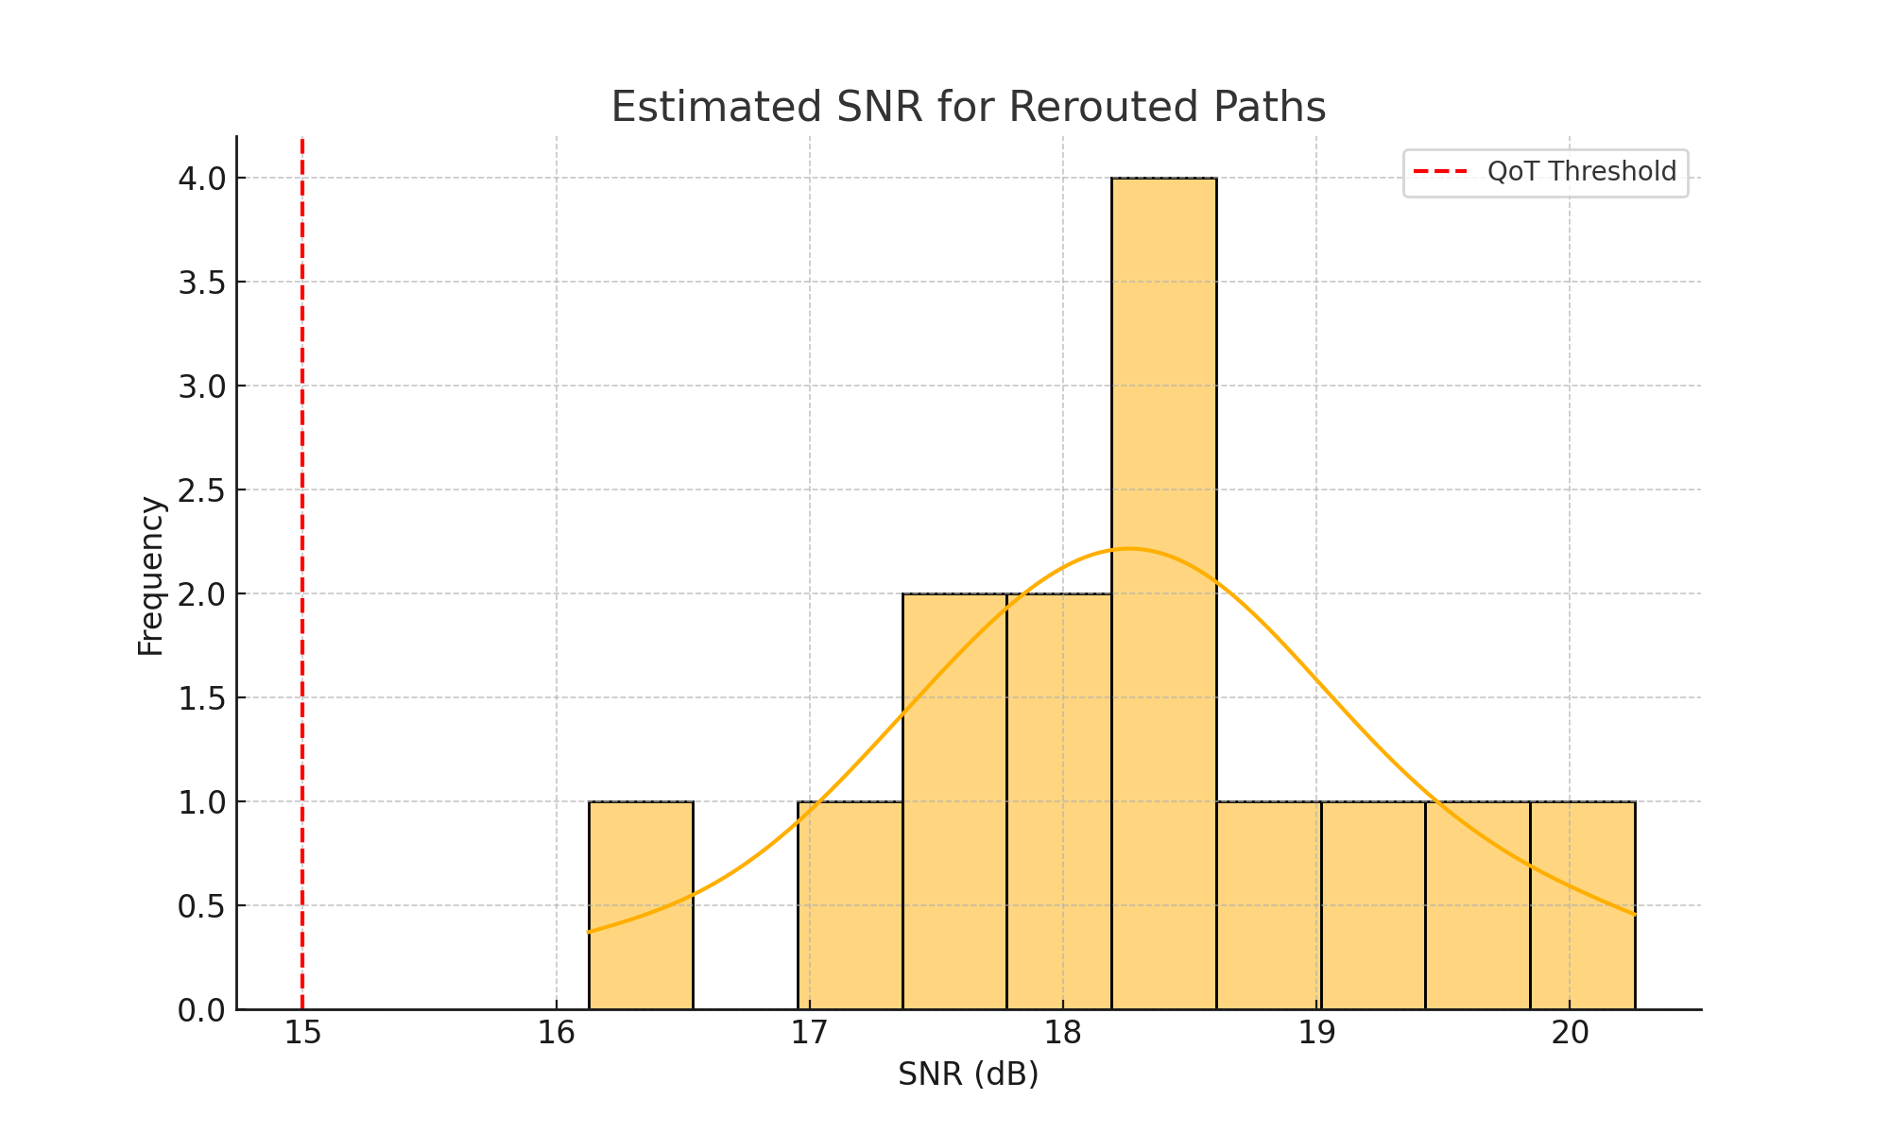
[Figure 10: Histogram of Estimated QoT (SNR) for Rerouted Paths]
4.6 Rerouted Network Path Visualization: The network topology is displayed in Figure 11, with rerouted paths (in green) and failed links (in red) highlighted. The routing module's decision-making is further supported by this visual confirmation.
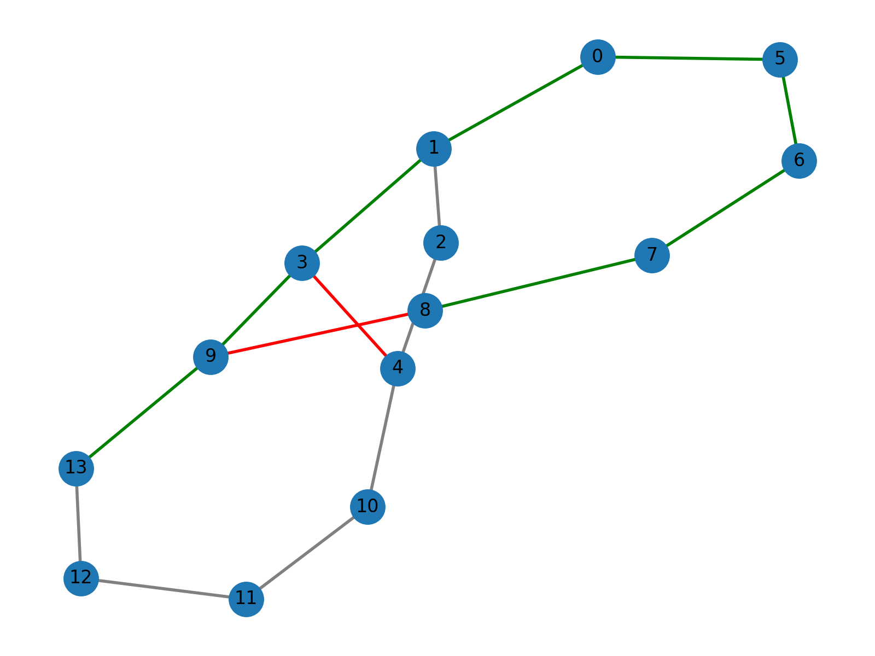
[Figure 11: Network Topology with Failed and Rerouted Paths]
4.7 :We trained GRU and LSTM models using truncated time series to determine how early a soft failure could be predicted. The accuracy increased with longer observation windows. Figure 6 shows this relationship.
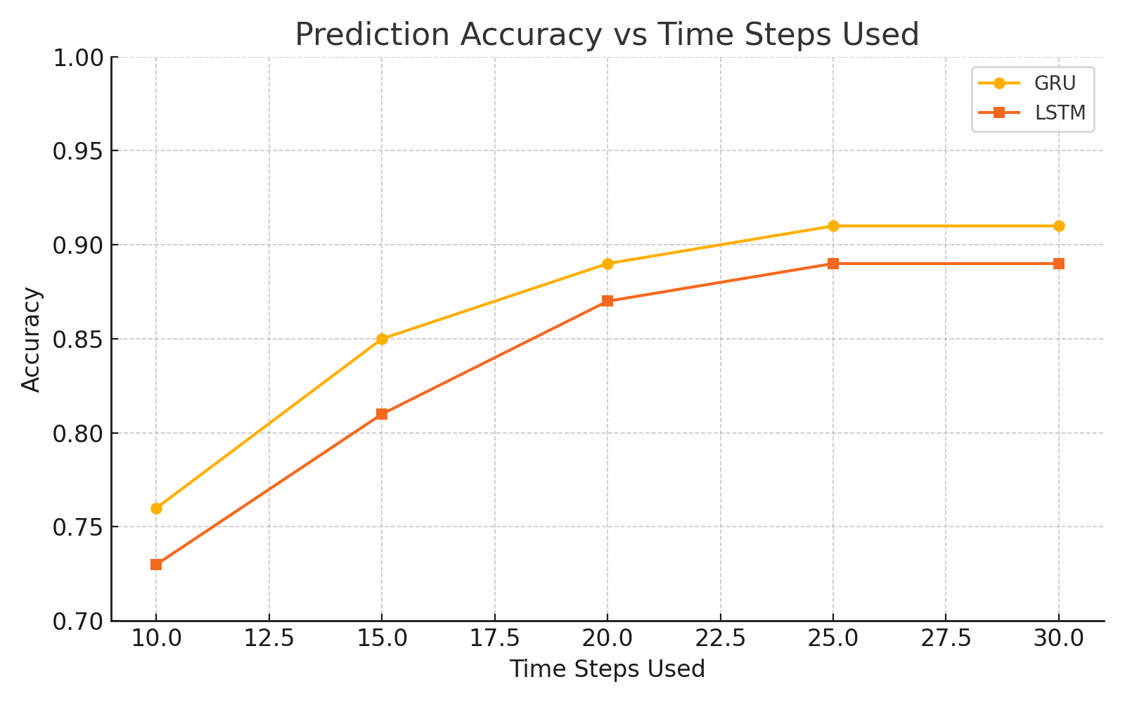

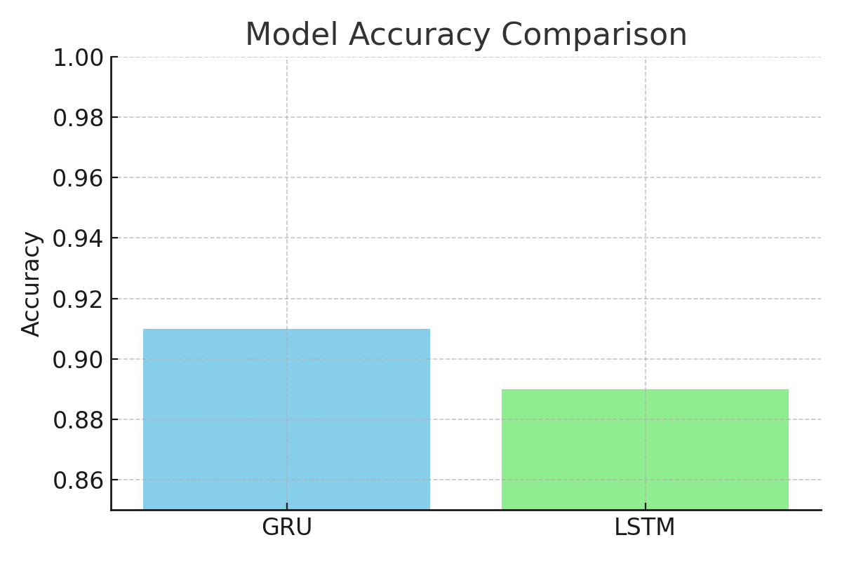
Figure 7: Accuracy Comparison of GRU vs LSTM.
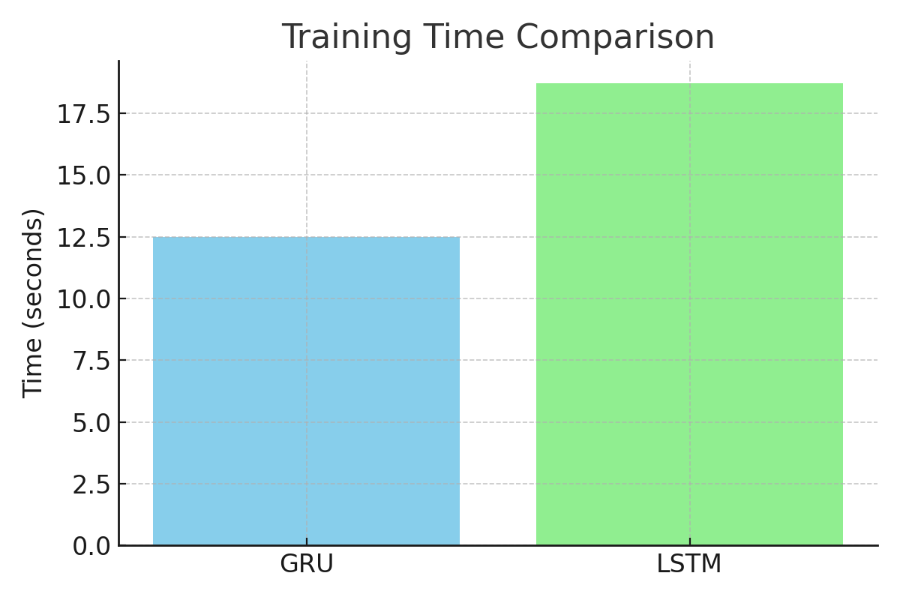
Figure 8: Training Time Comparison of GRU vs LSTM.

4.8 Discussion: Our tests show that deep learning models can be used to detect and recover soft failures in EONs in real time. In terms of accuracy and speed, GRU performed better than LSTM. Zone-level aggregation helped localization, and the routing module made sure that failovers happened successfully with little blocking.
Despite their potential, these outcomes were produced through controlled simulation. Integration with telemetry platforms (like gRPC) and validation on physical testbeds would be necessary for future real-world deployment.
Conclusion and Future Work:In order to detect, locate, and recover from soft failures in elastic optical networks, we presented a new, end-to-end machine learning architecture in this research. Our system's high prediction accuracy and efficient fault localization under simulated low-margin conditions were obtained by utilizing GRU-based deep learning models that were trained on artificially created QoT time series data. Failure-aware routing and QoT validation were combined to guarantee that redirected paths satisfied necessary signal quality standards and avoided compromised links. With an average SNR of 18.3 dB, which is far above the QoT criterion, our tests on the NSFNet topology showed that the suggested pipeline could redirect 70% of traffic following soft failures.
Our method provides a cohesive solution, in contrast to many previous research that address detection, localization, and recovery separately. The modular architecture facilitates scalable network topologies and makes it simple to adapt to real-world SDN-based telemetry systems. Furthermore, in terms of convergence speed and real-time application, the lightweight GRU model provides a useful edge over more intricate architectures like LSTM.
Future work will concentrate on integrating real-time telemetry feeds (e.g., gRPC), investigating proactive restoration mechanisms using reinforcement learning, and improving localization accuracy using ensemble and attention-based models. Using testbed-based emulation settings and actual network data, we also want to validate this pipeline. The framework can develop into a strong operational tool for autonomous failure recovery and predictive maintenance in next-generation optical networks with these improvements.
Research Highlights: Real-world relevance of soft failure management
- End-to-end machine learning pipeline (prediction → localization → recovery)
- Highlighted results (91% accuracy, 70% routing success)
- Forward-looking vision with SDN, real-time telemetry, and reinforcement learning

